Conference Article
Write Your Paper Title
Name Surname^{1*}, Name Surname^{2*}
¹ Affilation, Orcid ID: https://orcid.org/, e-mail,
² Affilation, Orcid ID: https://orcid.org/, e-mail,
* Correspondence: e-mail; mobile phone
(First received xxxxxx and in final form xxxxxx)
3rd International Conference on Design, Research and Development
(RDCONF 2023)
December 13 - 15, 2023
Reference: will be edited by editorial
Abstract
Xxxxxxxxxxxxxxxxxxxxxxxxxxxxxxxxxxxxxxxxxxxxxxxxxxxxxxxxxxxxxxxxxxxxxxxxxxxxxxxxxxxxxxxxxxxxxxxxxxxxxxxxxxxxxxxxxxxxxxxx.xxxxxxxxxxxxxxxxxxxxxxxxxxxxxxxxxxxxxxxxxxxxxx.
Keywords: Seamless denim, ultrasonic sewing, hot air bonding, hot press bonding
- Introduction
Xxxxxxxxxxxxxxxxxxxxxxxxxxxxxxxxxxxxxxxxxxxxxxxxxxxxxxxxxxxxxxxxxxxxxxxxxxxxxxxxxxxxxxxxxxxxxxxxxxxxxxxxxxxxxx [1].
- Materials and Methods
Xxxxxxx.
Table 1: Trial Data
Variables | Levels
Fabric composition | 96% cotton - 3% polyester - 1% elastane
Chemical | A, B
Xxxxxxxxxxxxxxxxxxxxxxxxxxxxxxxxxxxxxxxxxxxxxxxxxxxxxxxxxxxxxxxxxxxxxxxxxxxxxxxxxxxxxxxxxxxxxxxxxxxxxxxxxxxxxxxxxxxxxxxxxxxxxxxxxxxxxxxxxxxxxxxxxxxxxx
xxxxxxxxxxxxxxxxxxxxxxxxxxxxxxxxxxxxxxxxxxxxxxxxxxxxxxxxxxxxxxxxxxxxxxxxxxxxxxxxxxxxxxxxxxxxxxxxxxxxx.
  - Subtitle
Xxxxxxxxxxxxxxxxxxxxxxxxxxxxxxx.

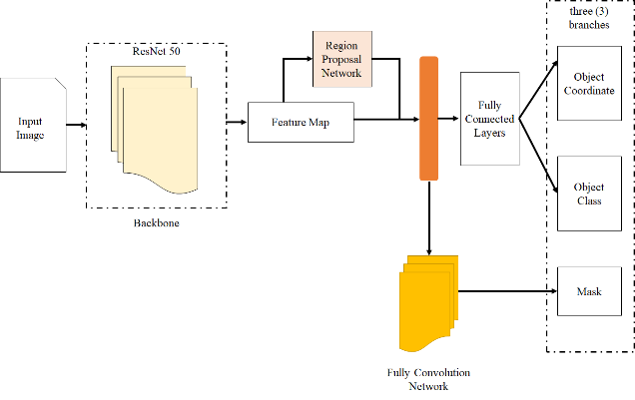
Figure 1: Seamless Denim Product
- Result
Xxxxxxxxxxxxxxxxxxxxxxxxxxxxxxxxxxxxxxxxxxxxxxxxxxxxxxxxxxxxxxxxxxxxxxxxxxxxxxxxxxxxxxxxxxxxxxxxxxxxxxxxxxxxxxxxxxxxxxxxxxxxxxxxxxxxxxxxxxxxxxxxxxxxxxxxxxxxxxxxxxxxxx.
- Discussion and Conclusion
Xxxxxxxxxxxxxxxxxxxxxxxxxxxxxxxxxxxxxxxxxxxxxxxxxxxxxxxxxxxxxxxxxxxxxxxxxxxxxxxxxxxxxxxxxxxxxxxxxxxx.
- Acknowledge
Xxxxxxxxxxxxxxxxxxxxxxxxx.
References
- IEEE Style must use
- Xxxxxxxx.
- Xxxxxxxxxxxx.

